

WEDE5020 POE PART 2

ST10066258

Tshedza Ramabulana

TRILLSA

2023

Table of Contents

**Website Choice** 2

**Website Assets** 3

**Website pages and content** 4

**Documented improvements to Part 1 process document** 5

**https://github.com/IIEMSA/wede5020-part-2-Tshedza2001** 7

**Documented improvements to the Part 1 website** 7

**References** 9

# **Website Choice**

The name of the business I have chosen to work on is called Trill SA. Its a company that makes and sells high-quality rugs for homes and businesses. The rugs are handmade by skilled artisans and are made with the finest materials. Which offers a wide variety of styles, colours, and sizes to fit any decor. TrillSA is a friend-owned business that specializes in high-quality, handcrafted rugs. They are committed to providing our customers with exceptional service and helping them find the perfect rug for their home or office. Which is again another reason to why I chose to work with the business.

With a website, you have the flexibility to develop an informational hub for your company. You can go into as much detail about your goods, services, and special selling point as you like, as long as you keep it intriguing.

You may improve your products or services with the help of consumer feedback, and you can also create more persuasive sales and marketing strategies for your website design. By appropriately analysing data, the expertise and information on your website help you make business decisions.

Building a relationship with your audience through websites, you can establish a connection with your audience. They provide you the chance to tell stories and immerse your audience in your universe. Making a website is highly advised if you want to establish a stronger connection with the audience you're attempting to reach.

# **Website Assets**

1. Determine what type of assets you need: For our rugs business, we need product images, lifestyle images, videos, graphics, and text.
2. Source high-quality images: We source our images from the manufacturer and take our own photos. We make sure that all images are high-quality and visually appealing.

* Film cameras: While less common than digital cameras, film cameras are still used by some photographers who prefer the look and feel of film. Film cameras capture images on film, which must be developed before the images can be viewed.
* Drones: Drones are becoming increasingly popular for aerial photography. They are equipped with cameras that can capture images from unique
  + Bird's eye view: In this angle, the camera is positioned high above the subject, looking straight down. It can create a sense of detachment or objectivity, and can also emphasize patterns or shapes.
  + Eye-level angle: This is the most common angle for photographs, where the camera is held at the same height as the subject's eyes. It creates a sense of familiarity and naturalness.

1. Optimize images for the web: We use Adobe Photoshop to optimize our images, reducing their file size without compromising image quality.
2. Write engaging product descriptions: We write detailed product descriptions that highlight the features and benefits of each rug, and provide relevant information such as size, material, and care instructions.
3. Create lifestyle images: We stage rooms with furniture and decor, and photograph our rugs in context to create lifestyle images.
4. Create videos: We create videos that show the different features of our rugs, such as the texture and colour.
5. Create graphics: We create graphics that highlight the different types of rugs we offer and provide information on how to care for them.
6. Organize our assets: We organize all our assets in a logical way, such as by product type or category, making it easy to find the assets we need when building our website.
7. Having a domain: This secures the website providing enough and efficient security in protecting the name.
8. Customer helpline: We will create a customer helpline which will respond to clients in need of assistance
9. POPIA compliance: Protecting people’s personal information is very important. This ensures that they will gain our trust.
10. Banking details: for online banking: A portal which will direct the money into the company’s business account

# **Website pages and content**

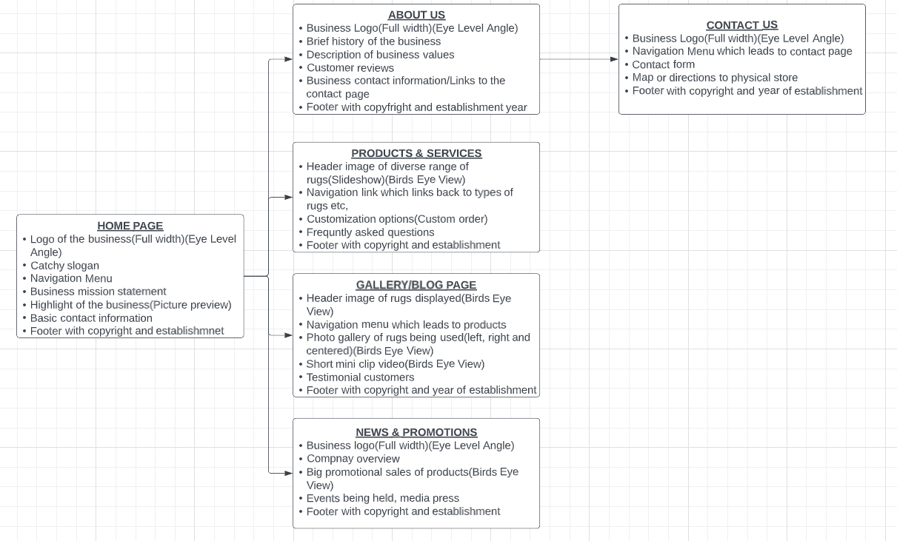

# **Documented improvements to Part 1 process document**

There was no need to add improvements to the process document as I had received full marks for it, with the lecturer adding no further comments concluding that no improvements where needed.

Below is the proof provided.

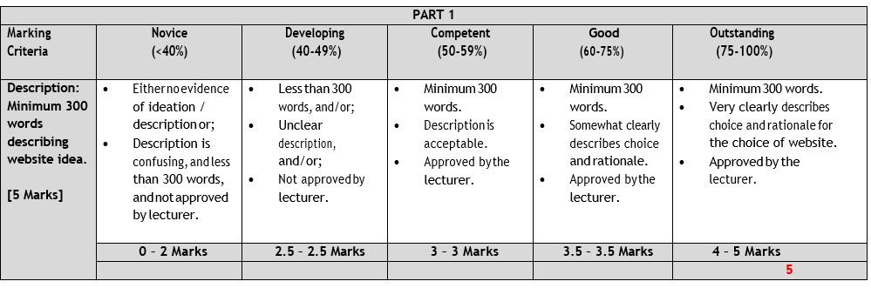

# [**https://github.com/IIEMSA/wede5020-part-2-Tshedza2001**](https://github.com/IIEMSA/wede5020-part-2-Tshedza2001)

# **Documented improvements to the Part 1 website**

I have ensured that all redundant spaces are removed and that I have at most one line of space between code segments for my code to be more readable to people that will be viewing my code. I also made sure that I added one line of spacing between the header and the main tag, and between the main and the footer tag to make my code more readable. I added as well of couple changes to the website by including some css styles to it.

Index page:

1. Removed the navigation menu from an h4 it was not needed.
2. Line 3 and 109 I added a space in between for the html tag
3. Line 3 and 8 I added a space in between for the head tag
4. Line 10 and 26 I added a space in between for the header tag
5. Line 10 and 110 I added a space in between for the body tag
6. Line 80 and 108 I added a space in between for the footer tag
7. Line 28, 78, 80 I added space to accommodate the main tags
8. In Line 30, 36, 40, 42,93, 96 I added centre tags
9. In line 44, 46, 51, 56, 61, 66 and 71 to accommodate the css code for the product images.
10. Along with adding the link style sheet in line 6
11. In the Index page I added image columns to make the page more appealing

About page:

1. Removed the navigation menu from an h4 it was not needed
2. The HTML code for the copyright symbol (©) is &copy;.
3. Line 3 and 8 I added a space for the head tag
4. Line 10 and 81 I added a space for the body tag
5. Line 10 and 25 I added a space for the header tag
6. Line 75 and 79 I added a space for the footer tag
7. Line 28, 40, 54, 73 I added space to accommodate the section tags
8. In line 31, 35, 42, 52, 57, 59, 65, 70 I linked the css styles

Products page:

1. Removed images side by side will not make the page look visually appealing.
2. Removed the navigation menu from an h4 it was not needed
3. Line 3 and 8 I added a space for the head tag
4. Line 10 and 87 I added a space for the body tag
5. Line 10 and 22 I added a space for the header tag
6. Line 24 and 79 I added a space for the main tag
7. Line 81 and 85 I added a space for the footer tag
8. Line 57, 68, 84 I added space to accommodate the section tags
9. In Line 28, 30, 51 and 65 I included css link styles

News page:

1. Removed the images on line 12 as there was no need to add content across the news and promotion page
2. Removed the images on line 21 as there was no need to add content across the news and promotion page
3. Line 3 and 58 I added a space for the html tag
4. Line 3 and 8 I added a space for the head tag
5. Line 8 and 56 I added a space for the body tag
6. Line 22 I added a space for the header tag
7. Line 22 and 50 I added a space for the main tag
8. Line 50 and 54 I added a space for the footer tag
9. From line 40 to 45 I included link styles
10. Line 30 and 34 I added center tags
11. Line 6 I added css link styles

Contacts page:

1. The HTML code for the copyright symbol (©) is &copy;.
2. Line 3 and 106 I added a space for the html tag
3. Line 3 and 8 I added a space for the head tag
4. Line 7 and 104 I added a space for the body tag
5. Line 10 and 24 I added a space for the header tag
6. Line 26 and 84 I added a space for the main tag
7. Line 86 and 102 I added a space for the footer tag
8. Line 26, 49, 51, 71, 84 I added space to accommodate the section tags
9. In line 31, 36, 41, 54, 88, 94 I added div class to include with the css style
10. In line 6 I added a css link style

# **References**

Smith, L. (2023, March 20). Welcome to Rugs Galore. Rugs Galore. <https://www.rugsgalore.com/>

Johnson, J. R. (2022). The Rug Company Business Plan [PDF]. Retrieved from <https://www.therugcompany.com/business-plan.pdf>

(pakpersiancarpet, 2020)

(Open House Pictures, 2022)